**Circuit Diagram**

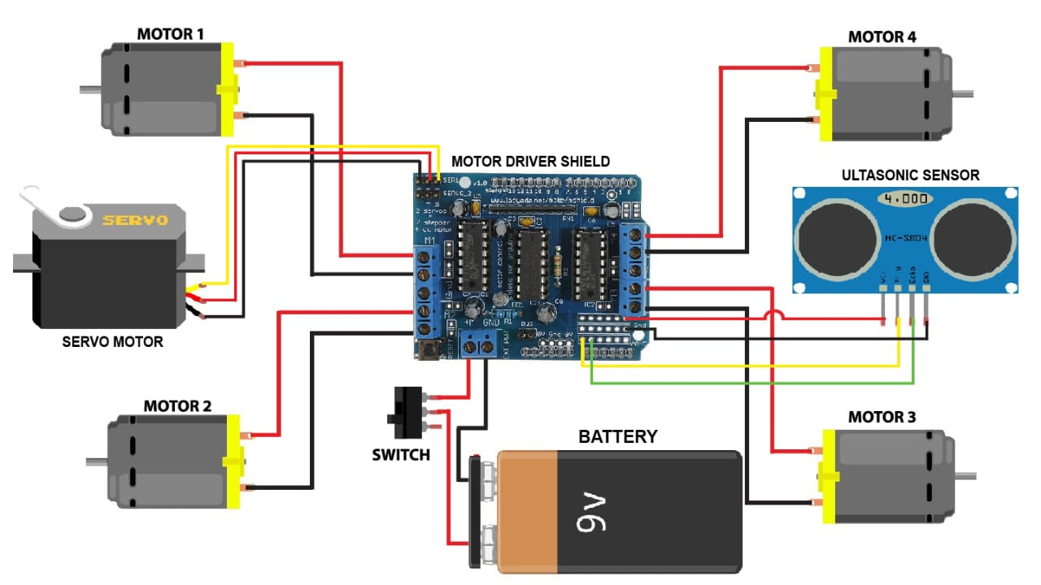

**Hardware Components**

1. **Arduino Uno**
2. **Motor Driver Shield (L293D)**
3. **Ultrasonic Sensor (HC-SR04)**
4. **Servo Motor**
5. **Switch**
6. **DC Gear Motors x 4**
7. **Chassis (Plastic)**

**Software Used**

* **Arduino IDE**